11-12-2015

Mariano Orozco García

Procesamiento de señales biológicas, 3BM4

Tovar Corona Blanca

Wavelets

Practice 6

***Practice 6 – Wavelets***

***INTRODUCTION:***

This is an introduction…

**Subtitle**

This is a paragraph…

***GENERAL PROPOSE:***

This is the general propose…

***PROCEDURE:***

This practice…

In order to implement this practice we use the following code:

function practice5()

end

In the code we include the following complementary custom functions:

function [time,val,Fs,labels] = readPhysionet(Name)

% Read mat File:

matName = strcat(Name, '.mat');

load(matName);

n = size(val,1);

% Read info File:

infoName = strcat(Name, '.info');

fid = fopen(infoName, 'rt');

fgetl(fid);

fgetl(fid);

fgetl(fid);

freqint = sscanf(fgetl(fid), 'Sampling frequency: %f Hz Sampling interval: %f sec');

Fs = freqint(1);

interval = freqint(2);

fgetl(fid);

% Read data of each signal

signal = cell(1,n);

gain = zeros(1,n);

base = zeros(1,n);

units = cell(1,n);

for i = 1:n

[~, signal(i), gain(i), base(i), units(i)] = strread(fgetl(fid),'%d%s%f%f%s','delimiter','\t');

end

fclose(fid);

% Baseline-corrects and scales the time series:

val(val==-32768) = NaN;

for i = 1:n

val(i, :) = (val(i, :) - base(i)) / gain(i);

end

time = (1:size(val, 2)) * interval;

val = val';

% Gives information of each signal:

labels = cell(1,length(signal));

for i = 1:length(signal)

labels{i} = strcat(signal{i}, ' (', units{i}, ')');

end

end

***RESULTS:***

In the first part…

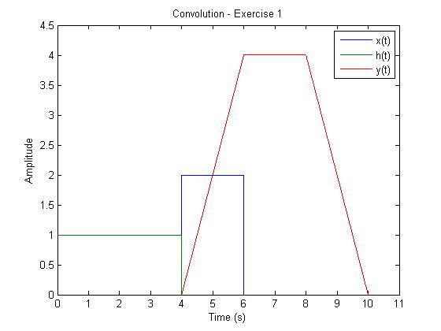

***Figure3.*** *Example figure.*

***CONCLUSION:***

This is the conclusion…

***REFERENCES:***

1. Jürgen Stutzki, Convolution, Autocorrelation, Cross-correlation, Power Spectrum: Fourier Transform and its Applications. Soummersemester 2007. Recovered from: [<http://hera.ph1.uni-koeln.de/~stutzki/teaching/FT_appl_2.pdf>].